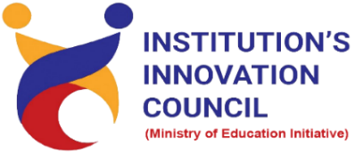
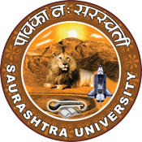
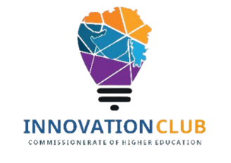
Entrepreneurship and Innovation as Career Opportunity for women
26 December to 30th December 2022
At
Seminar Hall, Department of Home Science,
Saurashtra University,
Rajkot

Contents
Saurashtra University - IIC 3
Event Schedule 3
Event Registration 3
Brief about Event 4
Key Points 4
Outcome 5
About the Speaker/Chief Guest 5
Connect Us 7

Saurashtra University - IIC
The university is dedicated to instruction, research, and extending knowledge to the public (public service). Ministry of Education (MoE), Govt. of India has established ‘MoE’s Innovation Cell (MIC)’ to systematically foster the culture of Innovation among all Higher Education Institutions (HEIs). The primary mandate of MIC is to encourage, inspire and nurture young students by supporting them to work with new ideas and transform them into prototypes while they are informative years. Saurashtra University is one of the organizations that have constituted the IIC to foster the vision of MoE and be a part of the promotion and development of the innovation ecosystem.

Event Schedule

Time | Program
8:00 am | Refreshment
8:15 am | Registration
8:30am – 8.45am Inauguration & Welcome
8.45 to 10:00am | Learn about importance of Entrepreneurship and innovation as career opportunity
10:00am to 10:30am | Break
10:30 to 1:00 | Learn about overall architecture of the Entrepreneurship life cycle
1:00 to 2.30 | Lunch break
2:30 to 4:00 | Expert session on topic how to convert the young graduate into innovative entrepreneur

Event Registration

bit.ly/ENT5-SUSEC

Brief about Event

SU Startup and Entrepreneurship Council (SUSEC) and IIC - Saurashtra University organizes a 5 Day Workshop on “Entrepreneurship and Innovation as Career Opportunity for women” at the Department of Home Science, Saurashtra University, Rajkot.
The workshop’s objective is to gain insights into start-ups and entrepreneurship, to promote the importance of Entrepreneurship and innovation as career opportunities and inculcate skillset required for a young graduates and women. In this workshop how to stimulate the overall architecture of the Entrepreneurship life cycle and how student can create innovative product by undertaking relevant methods was made understood by the speaker. Also, discussed how to demonstrate global entrepreneurship activity that India's share is growing and stands out.
Discussed about the need of entrepreneurship & innovation and skills and mind set of entrepreneurships. Speaker further made the attendees aware about the trends in entrepreneurship and innovation. He briefed the attendees about the risk and disadvantages of entrepreneurship and made the attendees realized the challenges where the start-ups failed to overcome.
The Program targeted to provide opportunities to Undergraduate students, Postgraduate students and Faculty members to expand their dexterities in various significant facets involved in building Career Opportunities in Entrepreneurship and Innovation. Expert orator has elucidated on how to be an entrepreneur focusing on core areas of the Business building like the relationship between Innovation & Entrepreneurship, Types of Entrepreneurs, Functions of an Entrepreneur, Barriers to Entrepreneurship, Qualities of an Entrepreneur, Circle diagram for startup, Internal & External Factors of Entrepreneurship.

Key Points
During the session, below mentioned points were discussed:
- Overview on Entrepreneurship Life Cycle
- India position on global entrepreneurships activity
- How to convert the young graduate into Innovative Entrepreneur
- How to start a new Innovative start-ups
- A Hands-on- Survey to check a graduate eligibility to become an entrepreneur
- Types of entrepreneurships
- How to start a startup
- Skills needed for small business Management
- FAQs related to Entrepreneurship and Innovation as Career Opportunity

Outcome
As per the event, students understood the basics of Entrepreneurship and its Importance in modern society. Skill set required to become an entrepreneur and how to convert simple ideas into innovation. The key performance indicator of a graduate likely to become an entrepreneur was made understood by the speaker.
The attendees’ understanding of the importance of innovation and entrepreneurship as career options was enhanced after attending the workshop. Also, understood the risk and disadvantages of entrepreneurship and e reason for the failure of start-ups. The attendees’ understanding of the trends in entrepreneurship increased after attending the workshop.
After completion of the workshop, participants can acquire more knowledge on Entrepreneurship and innovation as career opportunities.

About the Speaker/Chief Guest

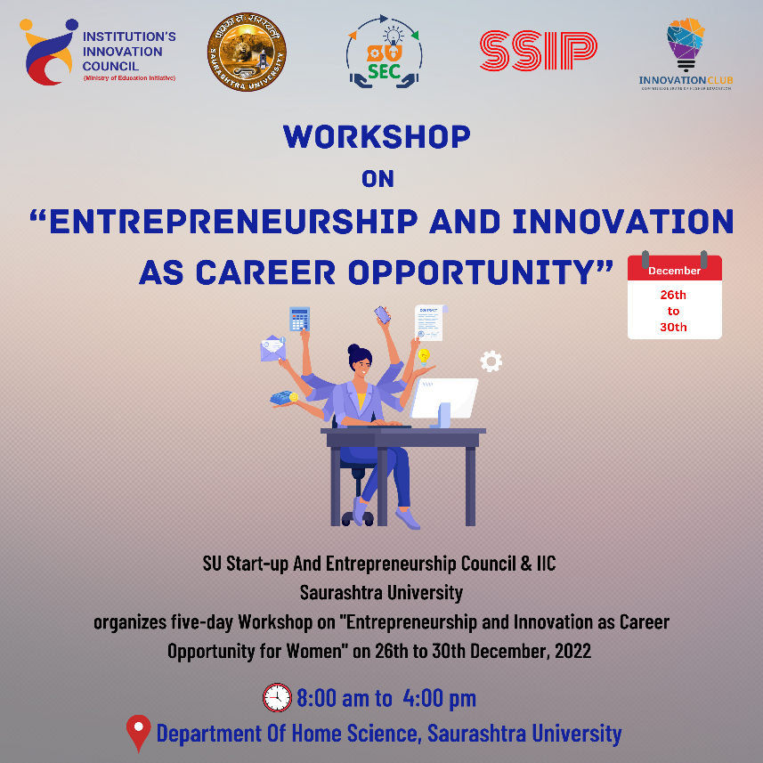

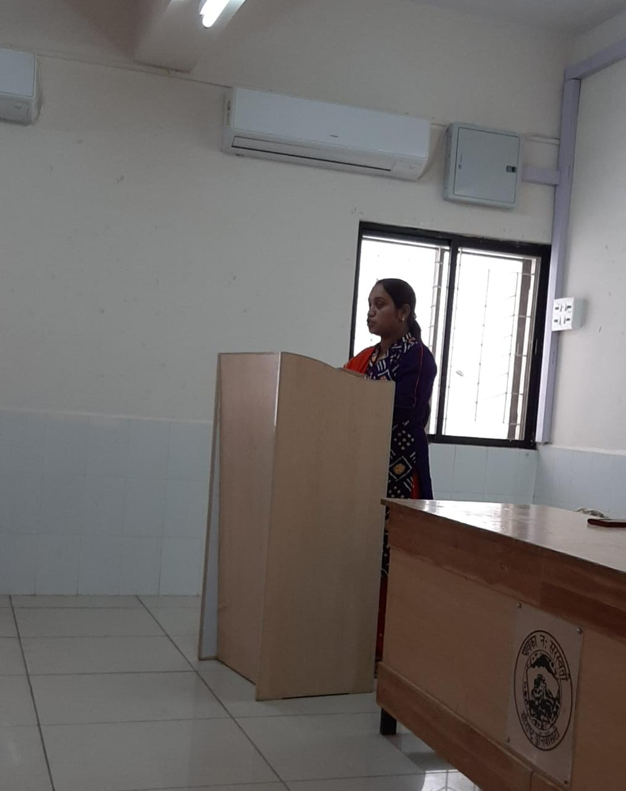
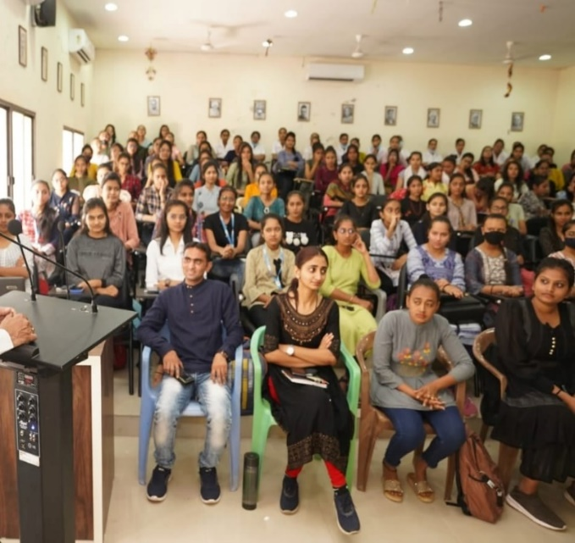

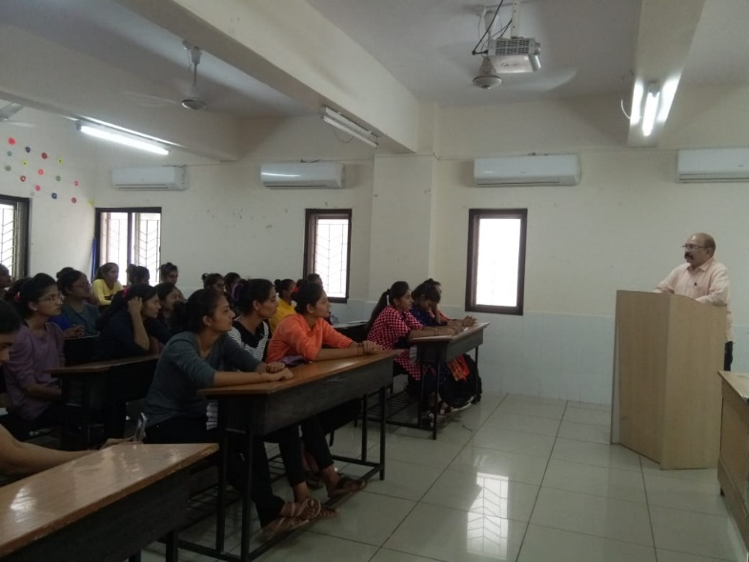
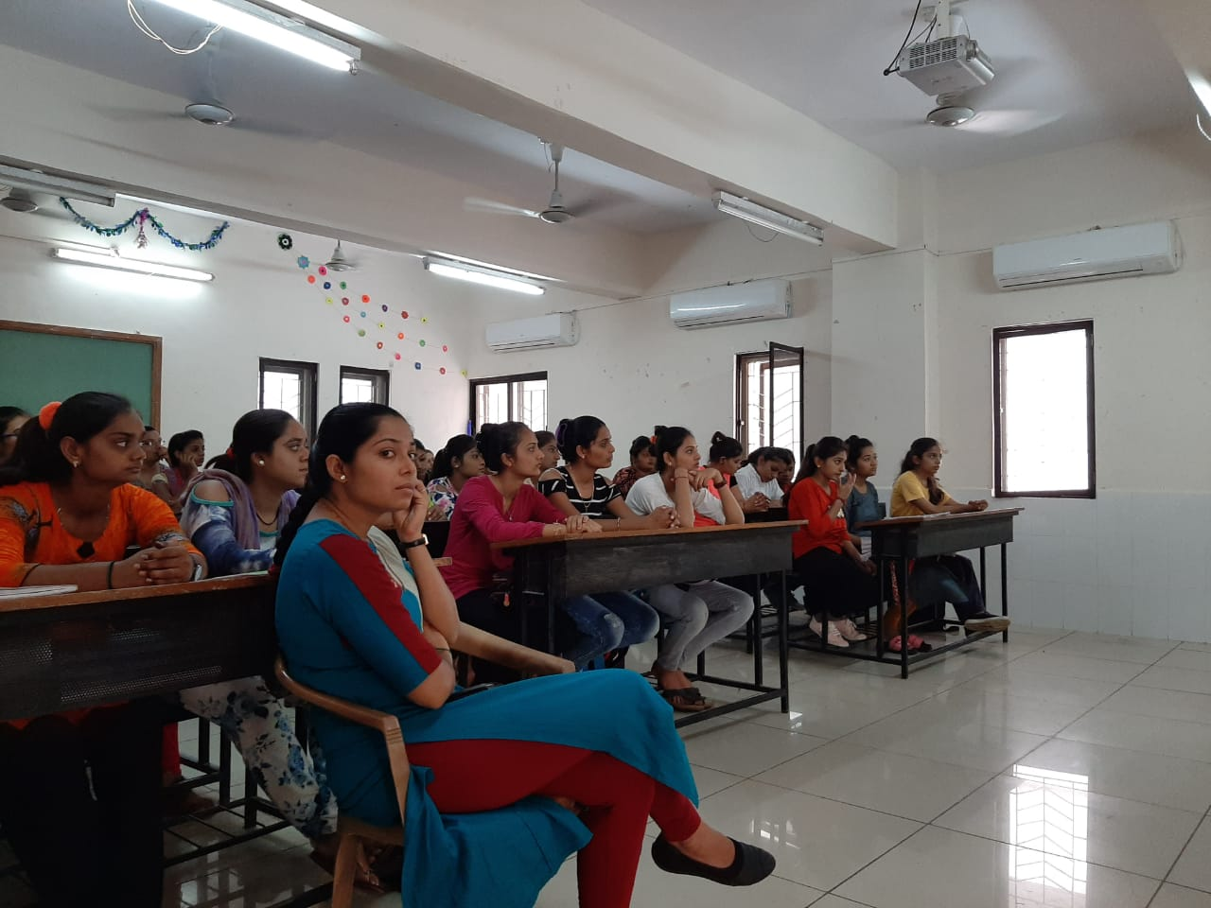
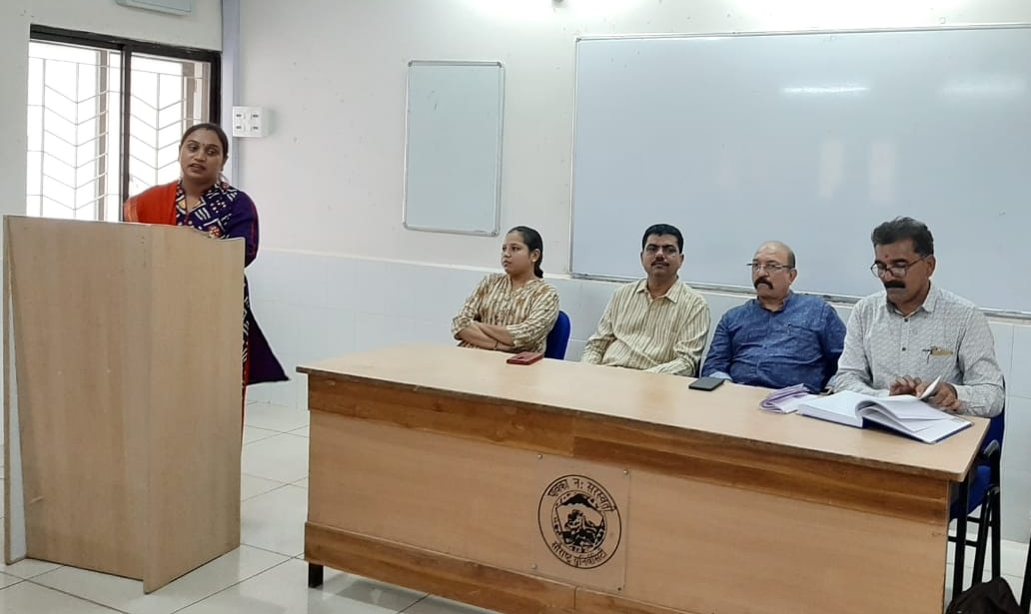

Connect Us

https://www.linkedin.com/company/susec iic@sauuni.ac.in
https://www.facebook.com/iicsauuni bit.ly/SUSEC-Location
https://www.instagram.com/susecrajkot https://bit.ly/SUSEC-youtube

